Let’s Go
CHURCH CAMP’N!

OCT 11-13, 2024


Mount Sterling Nazarene Family Camp 2024
We are so excited for Mount Sterling Nazarene Family Camp!
This year’s camp will be held from Friday, Oct 11th - Oct 13th at
Ludlow Falls Camp, located at 2500 OH-48, Ludlow Falls, Ohio 45339.

In this camp packet you will find the following:
- Camp Introduction Page (p1)
- Letter from Pastor Phil (p2)
- Registration Process information (p3)
- Sign Up Information (p3)
- Camp Schedule: Meals, fun activities & family worship times (p4)
- Event Registration Form (p5-6)
- Camp Map/Pictures (p7-9)

There are several accommodation options available at this camp. The spreadsheet included in this packet has a breakdown of the total camp cost per lodging choice, as well as any additional camp expense, to help you find the right fit for your family’s needs.
**amounts are based on a 2-night stay**

You can find information about the campgrounds at ludlowfallscamp.org
Last year many of us took a chance on a weekend away with our church family and …
WE LOVED IT!
We went to Ludlow Falls, Ohio for 3 days and 2 nights. Many of us participated in relays, field games, resting, worship, lots of laughter, and times of reconnecting over campfires.

Regularly scheduled times together, like reunions and retreats, are important times to reconnect and enjoy life with others. I long to see our families building community, especially Christ-centered formational communities, at Mt. Sterling Church.

In planning this experience of Family Camp, we are planning times of meaningful worship, some planned family activities, space for families to retreat and rest on their own, as well as common meals. Ludlow Falls Campground is a unique campground with many private housing units. The campground is located right beside Ludlow Falls and Ludlow Creek which will provide moments of kids playing in the water as well as time to relax by the water falls. Unlike many other campgrounds, the shared bathrooms are clean and modern. Many cabins have their own private bath. The housing and grounds offer places to take walks, play field games, use fire pits, etc. Specifically, Ludlow Falls is located approximately an hour from Mt Sterling, making it close enough to come after football games or to leave and return for Saturday soccer games.
I hope after reading this, you will become excited about the possibility of Family Camp. Give it a chance.

Don’t hesitate to contact the church office with any questions or for more information.

Pastor Phil Starr

Camp Registration Process

We will be offering paper-only registration for this camp.
Forms will be available in the church lobby or office or online at www.msnazarene.org to print and complete beginning on Sunday, August 18th, 2024.
Please return completed forms to Kara Mason in the church office.

Contributions

We are hoping to make camp affordable for everyone. However we are still asking people signup to bring some of the following:

1) FEE - Family amount needed for camp (see cost sheet included)

2) A SIGN UP FOR SMALL ITEMS WILL BE SENT TO THOSE
REGISTERED IN ORDER TO HELP WITH SMORES, CHIPS,
AND OTHER SMALL SNACKS.

3) SIGN UP TO HELP WORK - In the spirit of teamwork and to help keep camp organized so everyone can get the most from this experience, we are asking that everyone take a turn in helping with the preparation, set-up, and cleanup of meals. There is a signup at registration for meal assignments including meal preparation, setting up tables/dinnerware, serving, and cleanup after the meal. Everyone is welcome and encouraged to help with cleanup even if you’re not assigned to that meal!

Camp Schedule
Below is a tentative schedule of our weekend away. Our creative wheels are turning and we are constantly thinking of new ways to have fun, relax, and be together.
Friday
4:30-6 PM Check In
6-7 PM Dinner
7:30 PM Worship in Tabernacle
8:30 PM S'mores & Fire Pit

Saturday
8:30 AM Breakfast in Cafeteria
9:30 AM Worship in Tabernacle

10:30 AM Open Time (Volleyball, Softball, Kan Jam,
Corn Hole, Scavenger Hunt, Board Games,
Falls, Fire)
12-12:45 PM Lunch in Cafeteria
1:00 PM Relay Races Kick Ball
3-5 PM Open time (Games, Buckeye Game)
6 PM Dinner in Cafeteria
7:00 PM Worship in Tabernacle
8 PM S’more’s & Fire Pit

Sunday
10 AM Worship in Tabernacle
11 AM Group Photo by Fire Pit
11:30 AM Brunch in Cafeteria

Available Activities: Night Hike, Basketball in Gym, Waterfall Visits, Kickball, Group Games, Park for Kids, Board Games, OSU Game, Kids Park, and more.

Event Registration Form – Kaos

Event Registration Form
Mt. Sterling Nazarene Family Camp 2024

Total Number of People in your Group: ______

Name: Age: T-Shirt Size:
1._______________________________ ______________ _____________
2._______________________________ ______________ _____________
3._______________________________ ______________ _____________
4._______________________________ ______________ _____________
5._______________________________ ______________ _____________
6._______________________________ ______________ _____________
7._______________________________ ______________ _____________
8._______________________________ ______________ _____________
9._______________________________ ______________ _____________
10._______________________________ ______________ _____________

Home Address:

Phone Number: Email:

Emergency Contact: Phone Number:
***WE WILL NEED TO HAVE A COMPLETED MT. STERLING NAZARENE CHURCH ACTIVITY WAIVER ON FILE FOR EACH PERSON IN YOUR GROUP WHO WILL BE ATTENDING THE CAMP. WE WILL HAVE EXTRA WAIVERS AVAILABLE AT THE CAMP AT CHECK-IN.

Please write in your housing choice: (Housing choices are first come, first served. The cost for housing is the following ($50 - Private Cottage with Shower, $40 - Private Cottage without Shower but with Toilet, $4.00 per person to reserve a Dorm room using Shower Houses))
A -1st Housing Choice: _________________________________ Housing Cost: $____________
2nd Housing Choice: __________________________________ Housing Cost: $____________

B - Your Group’s Total General Camp Cost ($23.00 X ______ # of People): $____________
C - Your Group’s Add’l Expense : ($15.00 X ______ # of people) $50.00 Max $____________
D - Your T-Shirt Expense: ($10.00 X _______ # of people) $____________
Total Camp Cost: (A + B + C + D) $290 is Max per Housing Group $____________

Optional Items:
______ YES, I would be willing to use a cottage while sharing the Shower/Bath Houses to help others with their preferences.

______ YES, Scholarship Funds would help me make Family Camp a Stress Free Priority.

Camp Check-In will begin at 4:30 pm on Friday evening.
If your group will be arriving at camp later in the evening, please let us know when you will be arriving so that someone is available to help you get checked in and to your dorm/lodge room/cottage. Anticipated Check-In Time: _________________________

Camp Check-Out time will be after BRUNCH on Sunday. You will need to have all your housing area cleaned up and leave the camp no later than 1 PM on Sunday.
IMPORTANT CAMP RULES:
Alcohol, Tobacco, Controlled Substances, Fire Arms, etc. are prohibited at all times on the campground.
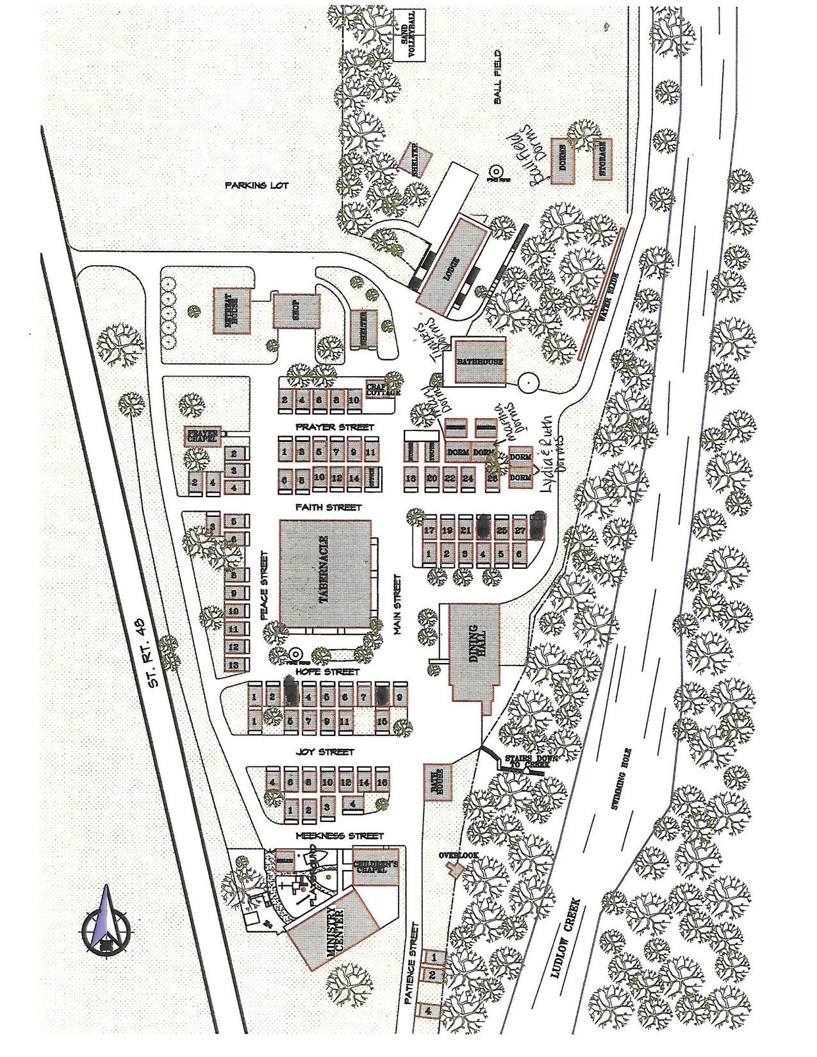PICTURES OF AVAILABLE ACCOMMODATIONS

DORMS
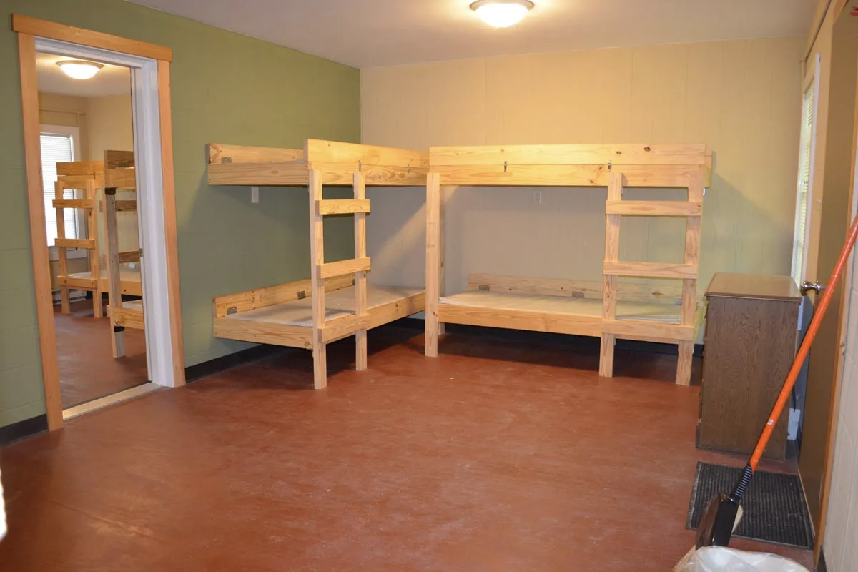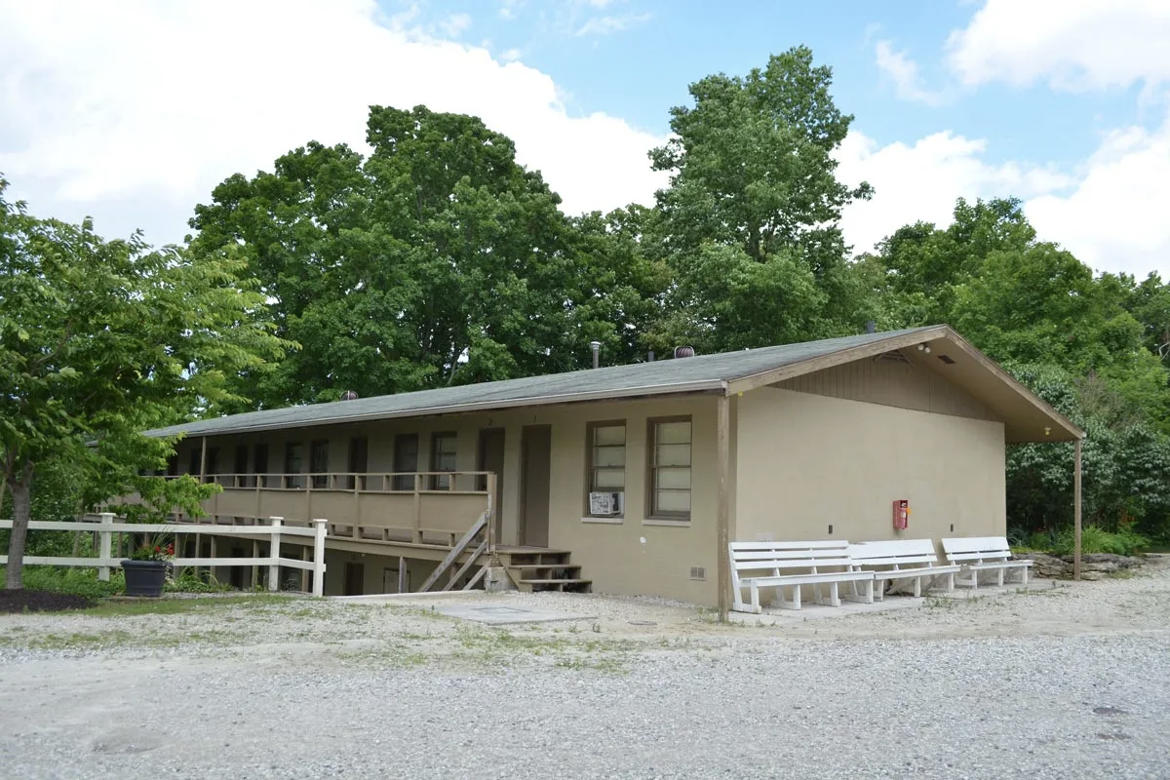

LODGES
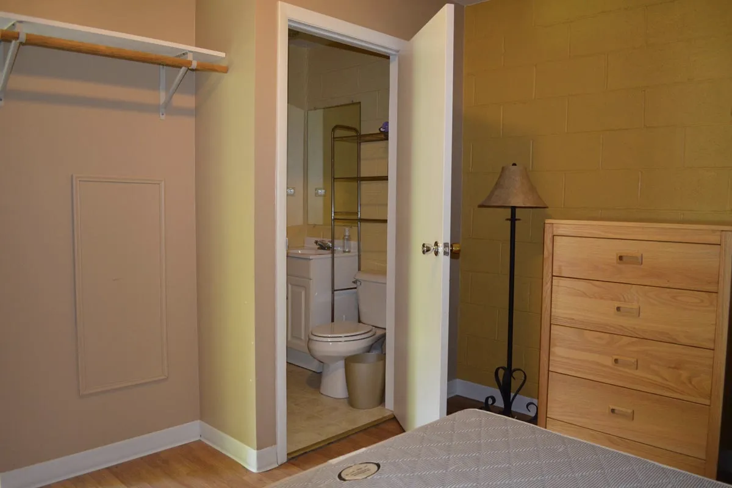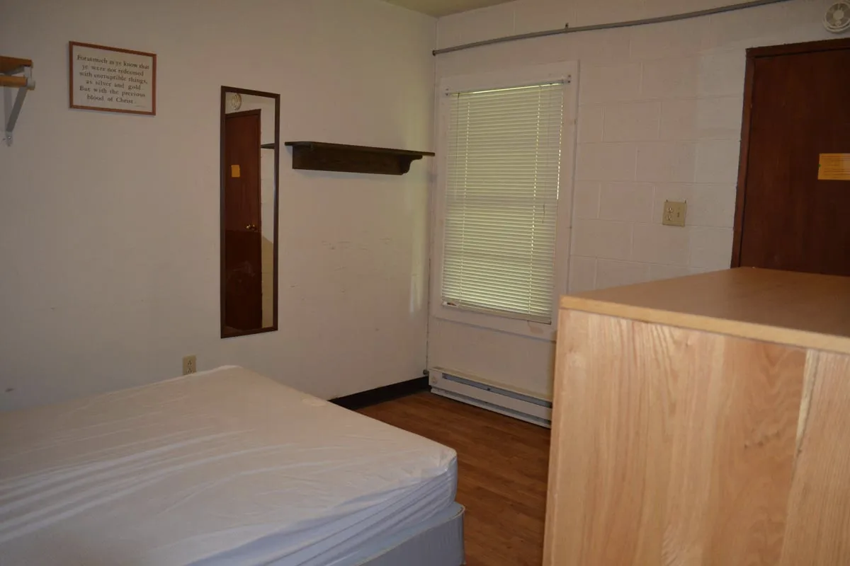

COTTAGES

